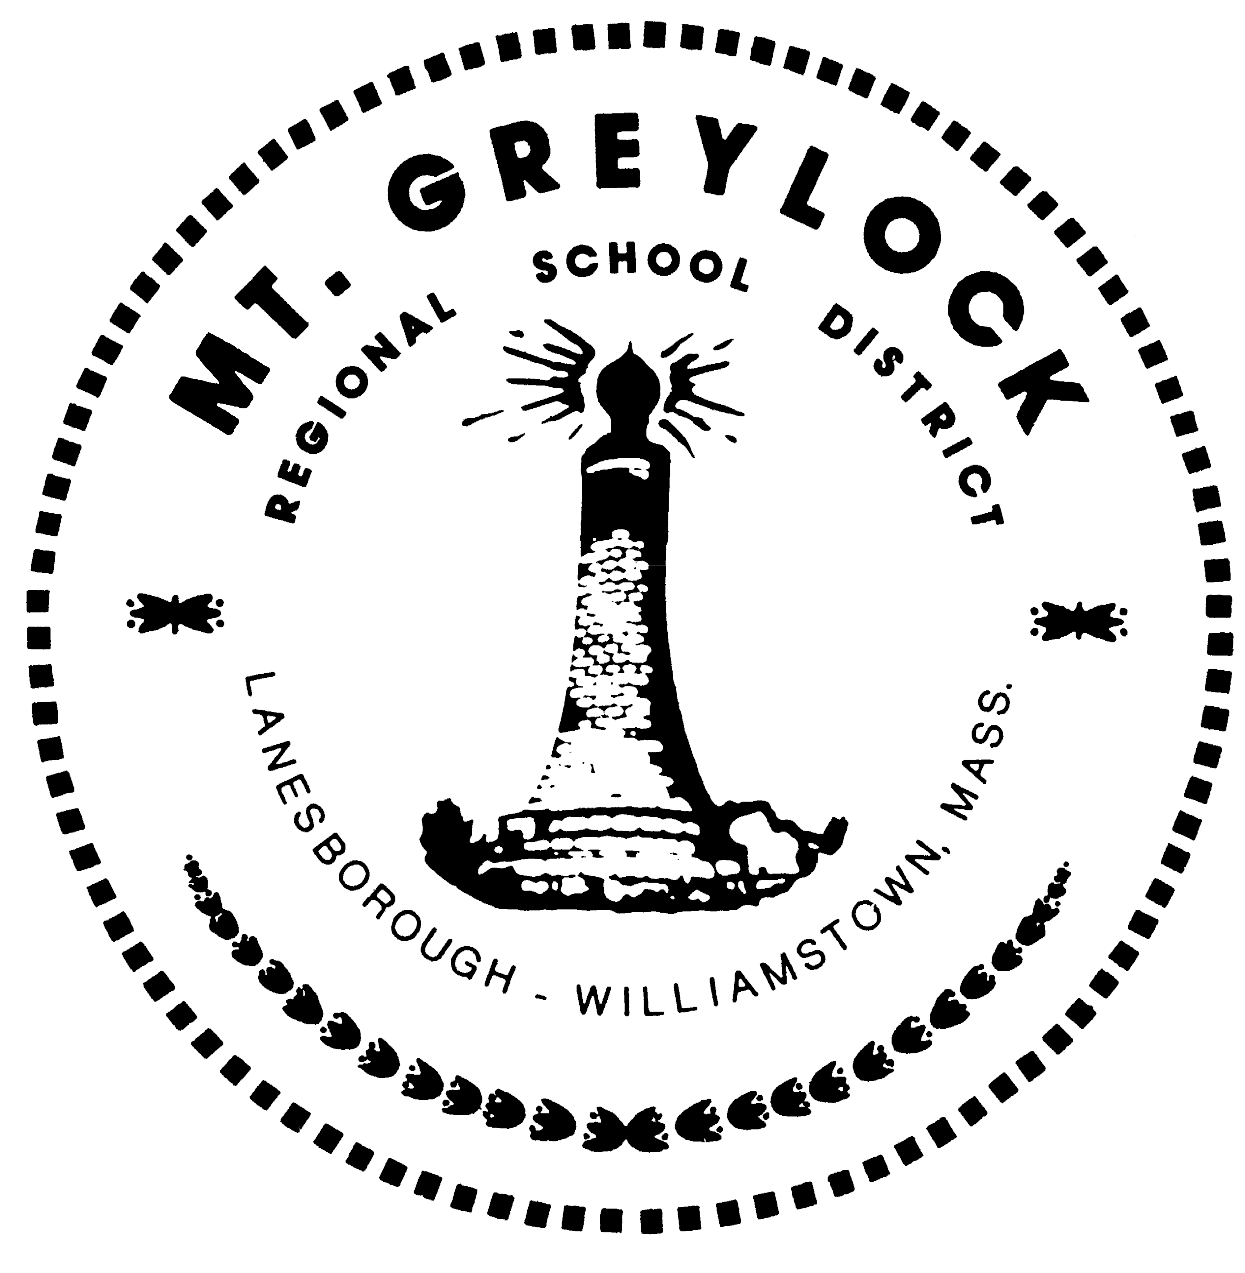

Williams College Fund for Mount Greylock
Fall 2013-Summer 2014

Office of the Superintendent – Dr. Rose Ellis
Office of the Principal – Mary MacDonald

The Williams College Fund for Mount Greylock continues to provide transformational funding for department and whole school professional development, for creative teacher- and student-designed projects, and for the technology to support them. This pivotal investment has given Mount Greylock teachers, administrators, students, and parents the ability and time to learn from experts, to listen to and inspire each other, and to collaborate innovatively in ways previously unavailable. Interdisciplinary projects have grown, involving math, science, English, and the arts. New technology has advanced both inquiry-based learning and more thorough ways to assess many kinds of learning. Co-curricular activities have expanded, along with new relationships among parent groups, the Williams Center at Mount Greylock, and other community organizations.

The fund received additional gifts in 2013-14. Two donors gave a combined $9,500 toward the fund’s general purpose of supporting innovation at the school. Another donor provided $32,500 for the related purchase of two portable technology carts, which incorporate a total of 50 laptops, for use in middle school classrooms.
Fund-supported initiatives can be divided, with some overlap, into those involving professional development, the expansion of curricular and co-curricular opportunities, and the deepening use of technology in learning and its assessment.

Professional Development

- While we have used the fund for professional development throughout the school, we focused particular attention in the first year on mathematics and in the second on science. The focus in this third year was on social studies. The International Center for Leadership in Education (ICLE) worked with department members to assess student needs and to coach faculty on instruction. The department will now develop a vision and strategic plan, leading to a redesign of the courses and their sequence.

- Instructional coaches partnered for a third year with math faculty on teaching strategies and on developing the curriculum and aligning it with Common Core Standards.

- Two math teachers incorporated new assessments and technology gathered from a conference of the Massachusetts Computer Using Educators.

- The ICLE continued to work with all science teachers to align the curriculum with the Next Generation Science Standards, expand inquiry-based learning, and infuse technology into instruction and assessment.

- All middle and high school faculty attended the National Science Teachers Association conference in Boston.

- Mount Greylock and Williams faculty and students collaborated on labs and units in the sciences and social studies to deepen middle and high school students’ experiences of inquiry-based learning.

- With the help of summer training, faculty continued to build on work begun in the first two years of the fund in devising and implementing strategies to advance students’ literacy across the disciplines and at all grade levels.

- A group of middle school teachers continued to work on strategies to build community and manage classrooms.

- Six teachers attended College Board-sponsored summer seminars on the teaching of Advanced Placement Chemistry, Latin, Physics, Spanish, and Statistics.

- 8th grade science teacher Sue Strizzi worked with a Williams student to develop new lab units on the industrial revolution and on climate change.

- Lynn Lyons and Maria Trozzi, experts in the fields of adolescent development, crisis management, and bereavement in school communities, worked with faculty, students, and parents.

- A team of sophomores and juniors joined teachers and administrators at a conference on bullying prevention sponsored by the Massachusetts Interscholastic Athletic Association, with a focus on bystander awareness.

- As a way to introduce students to choral performance and to begin building community before they even get to Mount Greylock, choral director Kate Caton organized and directed a month-long choral festival for grades 4-9 from Hancock Elementary, Lanesborough Elementary, Williamstown Elementary, and Mount Greylock. The final performance celebrated this new collaboration.

The opportunity to work closely with instruction coach Erika Tate to redesign my curriculum so it addresses the Next Generation Science Standards, incorporates more technology, and is inquiry-based means so much to me. Students are asking questions and taking ownership of 8th grade science in ways they never have. I also appreciate the chance to attend the 2014 National Science Teachers Association Conference. I learned so much from the seminars and exhibitions, but also from talking to my colleagues between sessions. When a Williams faculty member proposed doing Bio-Eyes with my students, my students and I were prepared and eager.

Sue Strizzi, 8th Grade Science Teacher and Team Leader

Curricular and Co-curricular Expansion

- Three students studied Mandarin using a curriculum developed for them by the Williams Asian Studies Department. Williams students provided twice-weekly instructional support. The course will continue next year with four students.

- Students pursued independent work in fashion merchandising, French, German, microbiology, and website development.

- Teacher Blair Dils developed a high school English elective, The Listening Journey, in collaboration with artist-in-residence Andrew Forsthoefel. The course uses digital technology to craft and mix sound collages that incorporate oral histories, music, and sound effects.

- The business and visual arts departments developed a unit that involves designing stained glass pieces to market in the school store.

- The English department developed a program to bring local authors to lead discussions or workshops. Participants included Jana Laiz, Williams faculty members Jim Shepard and Karen Shepard, and Williams senior and Mount Greylock graduate Dylan Dethier.
- Teacher Trudy Ames developed a unit that uses poetry to enhance visual literacy.

- The English and social studies departments collaborated on an effort to integrate forms of digital technology in the assessment of learning.

- A new vocabulary program incorporated strategies to develop 7th graders’ understanding and application of root words.

- Oral histories were twined with traditional 9th grade English texts as new lenses through which to approach literature.

- The first annual Ada Lovelace writing competition was held, in which students research and honor women in mathematics.

- The Spanish department began using Google Voice to enhance the development and assessment of students’ oral skills, including fluency and pronunciation.

- The Spanish department introduced a unit that incorporates Spanish and Latin American music with texts.

- Student Council representatives piloted a Model UN program and attended the Model UN Conference at UMASS.

- A student-developed speaker series #GreylockTalks, brought local experts to school to give TED-like talks on a range of topics.

- A student-developed mid-day concert series #GreylockPlays showcased student musicians in a variety of genres.

The unexpected benefit of my LCD projector was that I was suddenly collaborating with fellow English teachers in new ways. Last year, I shared a Dropbox folder with a colleague who was teaching the same class. Suddenly, she could see on her desktop every writing prompt, activity, or assignment that I posted on my board. This allowed for an easy conversation about subtle but important elements of our lessons that would not have taken place were it not for the projector. Without enough hours in the day to reach out and collaborate with colleagues as much as we would like, teaching can feel like a solitary profession; I was grateful to stumble upon this simple but valuable system for sharing ideas.

Rebecca Tucker-Smith, 9th and 10th Grade English Teacher

Technology

- A part-time instructor was added to support middle school efforts to use technology to meet Massachusetts Science Frameworks.

- The digital photography and video lab was completed with the installation of new software. Students’ photography was exhibited in MASS MoCA’s juried art show for northern Berkshire schools; student videos have been submitted to various contests.

- 39 LCD projectors have now been installed, covering 95% of all classrooms.

- 50 laptop computers were added to advance innovative teaching, learning, and assessment in the middle school.

A fuller analysis of the effects of fund-related initiatives on teaching and learning is scheduled for 2014-15, as part of our preparation for the school’s decennial accreditation self study. This will include surveying students, faculty, and parents and studying standardized test scores. Also, faculty and student recipients of WCF grants will give presentations on their projects, with a focus on assessing their impacts.

Williams College Fund for Mount Greylock
Expenditures in 2013-14

Professional Development-$46,806

Faculty and staff participated in local and distant exercises targeted at enhancing inquiry-based learning opportunities for all students. Work also continued around developing literacy skills across the disciplines and integrating technology more deeply in instruction and assessment.

This year, the history program undertook a review. As with the previous reviews of math and science, teachers, students, administrators, parents, and Williams faculty participated in a needs assessment. Next steps include working with a consultant to develop a cohesive vision that considers standards and student needs. A strategic plan for history will be crafted and implemented in the coming year.

In addition to academic professional development, faculty and staff worked with experts in adolescent psychology to examine how best to manage and support students who are experiencing loss, grief, fear, or anxiety. We expanded these sessions to include parents and community members.

Technology Instruction – $33,457

To engage students of all academic ability levels, we have added a course on non-digital technology to supplement the middle school science curriculum. Students learn about tools and about simple and complex machines. Complementing this course is a new high school club focused on digital technology, including circuit building, code writing, and 3-D printing. In 2014-15 the high school club will expand to an after-school program open to grades 7-12. It will evolve into a “maker space” incorporating elements of the old club and adding robotics (taught by Williams students), digital video, and photography.

Teacher Curriculum and Program Development – $9,278

Teachers can apply to the fund for financial support for projects, trips, speakers, and other initiatives. We judge proposals by how well they support the school’s long-range academic and civic goals and make innovate use of technology. Grant recipients present their plans in October and then give presentations about their outcomes in May. Examples of these projects are sprinkled through this report.

Academic Materials – $1,795

The fund purchased texts and supplies for the independent study of Mandarin and the new courses in Climate Science and Astronomy.

Student-Initiated Programs and Projects – $932

Student initiatives underwritten this year are listed above.

Technology – $97,673

The fund purchased technology training for teachers along with LCD projectors, upgraded software, and computers, including 50 laptops for middle school use. Money also supported the initial stages of an overhaul of the school’s website to make it a more powerful tool for teaching and learning and for communicating with students, parents, students, and the wider community.

