Here are some facts about my favorite objects in the Solar System, in response to a request from my grandson Sam.

Mars is a wonderful planet. It appears slightly reddish in the sky because its surface is largely reddish dust. In the early morning this week, before the Sun rises, Mars is between two brighter planets—Venus and Jupiter; all are easily visible in the eastern sky. Mars is just over half the size of Earth from side to side.

At the moment, NASA (our government's space agency) has a wonderful spacecraft called Curiosity that is crawling around Mars's surface. Curiosity has cameras to photograph the surface very well and also instruments to examine the dust and rocks on Mars's surface very carefully from close up. One of my former students, Katie Stack, just got her doctor's degree from Caltech studying Mars, and now she works for the Jet Propulsion Laboratory in California as one of the people in charge of Curiosity.
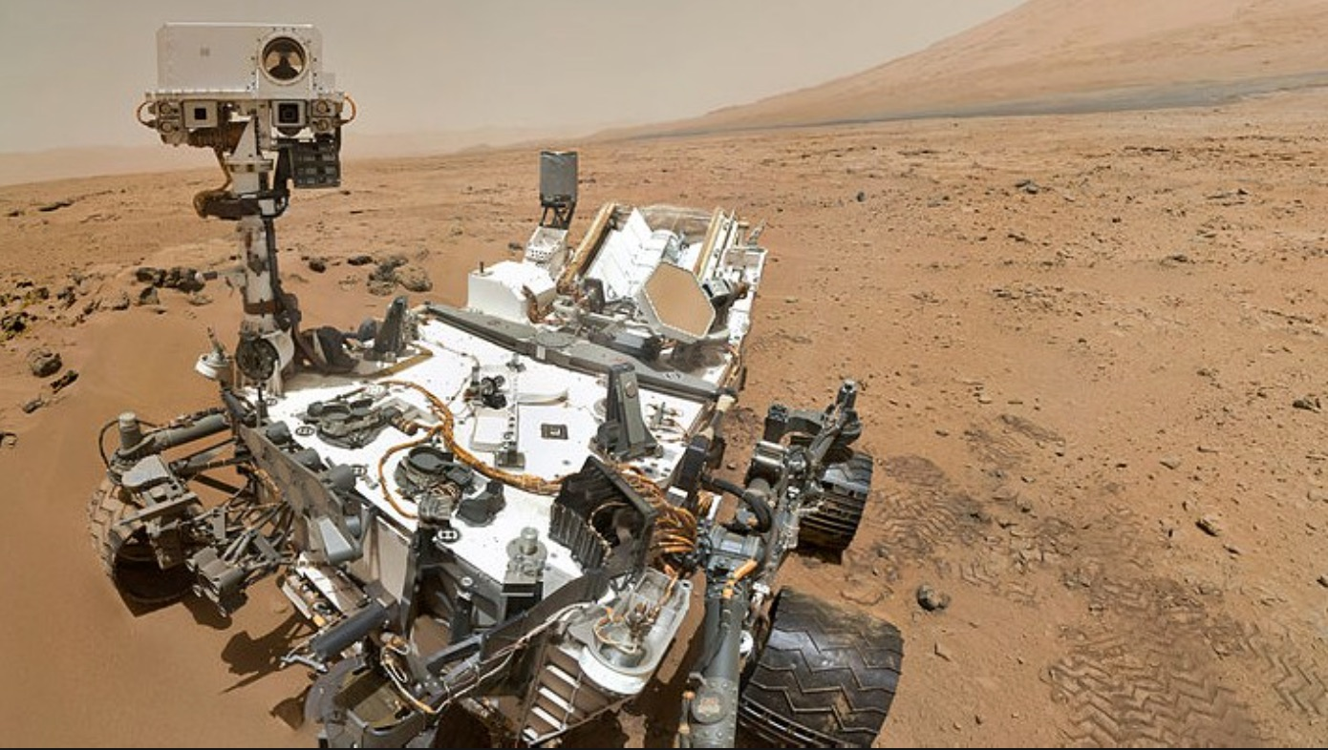

One of my students used a NASA spacecraft called Mars Reconnaissance Orbiter to look at pictures of Mars's surface. Last week, some researchers reported that they saw streaks on some martian hills that matched the way it would look if water appeared either from above or below and changed with the season. This week, other researchers reported that there used to be lakes of water on Mars. Many people are interested in discovering water on Mars because we think life on Earth began in water, and they want to know if life began by itself on Mars.
I personally think Mars is so interesting for its rocks and its atmosphere that I think people spend too much attention on whether there is life there. Anyway, we can't send Curiosity to examine sites where water has been reported because we worry that some bacteria on the spacecraft could get into Mars's water and then we could never know if we find life forms on Mars in the future whether they came from us.
There is a new movie, The Martian, about an astronaut who is left by mistake on Mars. But really, nobody will be able to go to Mars for at least twenty years.
Jupiter is a giant planet. It has over 300 times the amount of matter that our Earth does. It is 11 times bigger than Earth from side to side.

Jupiter can be very bright in the sky at any time of night. Jupiter and the other planets usually seem steady in the sky even while stars are twinkling, because the planets have tiny disks we can study with telescopes. The stars other than the Sun are so far away that they are just points in our telescopes.

A colleague and I made a study of Jupiter with the Hubble Space Telescope in 2012. We took 170 pictures of Jupiter, about half in the blue and half in the red. We watched Jupiter turn around twice, which took about 22 hours. The picture shows a pair of our images, printed together. You can easily see the Great Red Spot, a giant hurricane on Jupiter that has been there for more than 100 years.
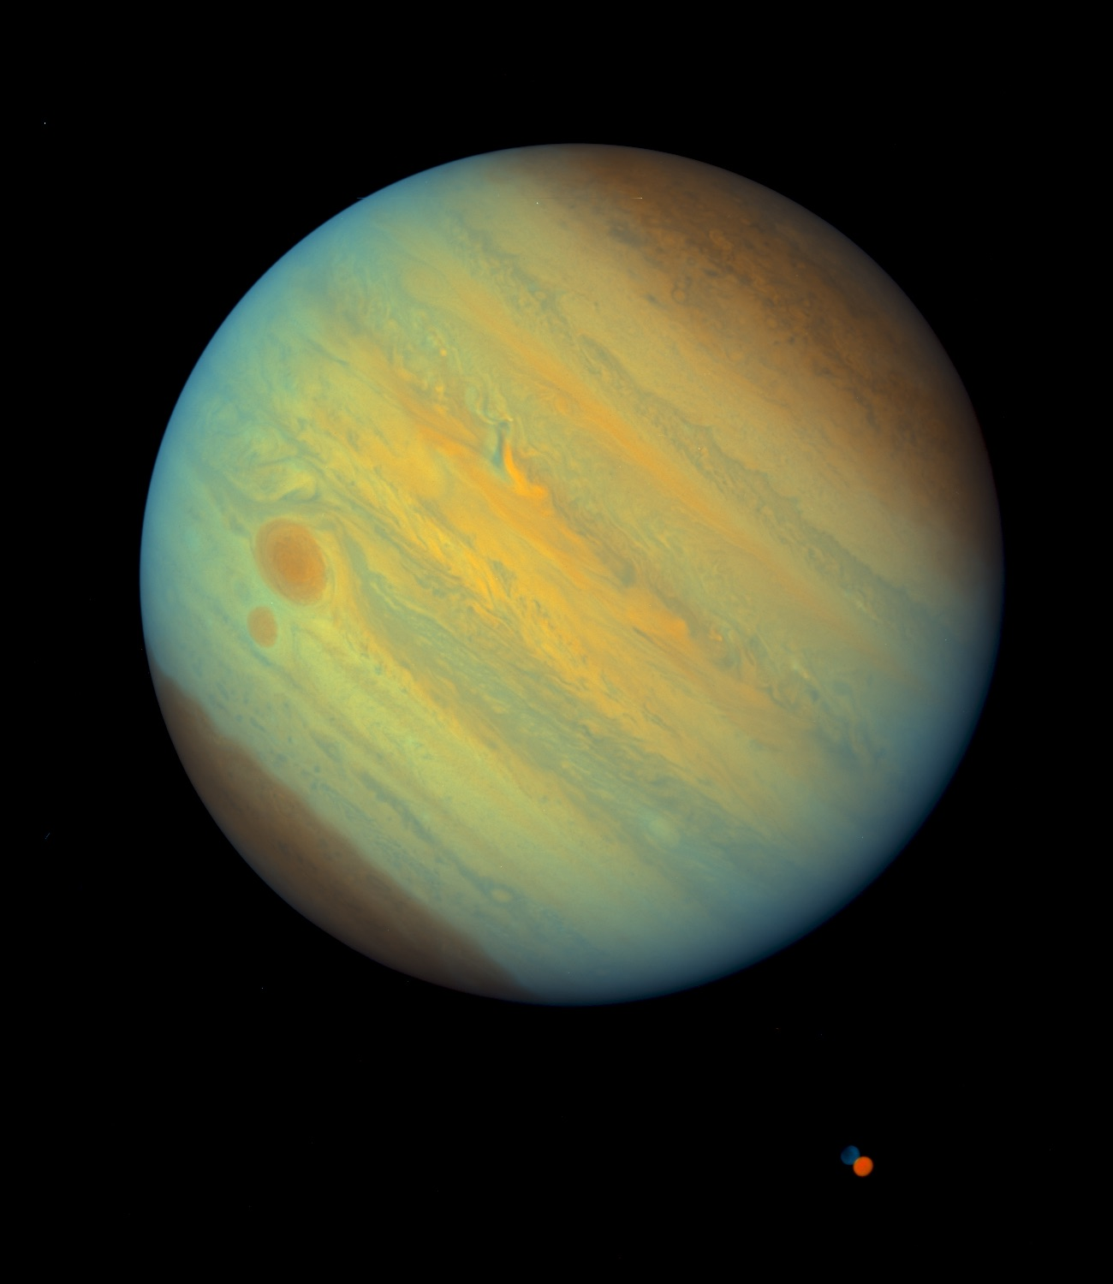
One of the interesting things going on in astronomy now is the discovery of planets around other stars, which are called "extra-solar planets" or just "exoplanets." Some scientists at the University of Arizona have used our 170 photos to test a new computer program they wrote to discover big spots on exoplanets, based on how the light from the exoplanets vary. Together, we have written a scientific paper that is being submitted to the Astrophysical Journal, a magazine for astronomers.''

NASA has a spacecraft called Juno that is on the way to Jupiter now. It will get there on July 4. In old Greek stories, Jupiter was the king of the gods and Juno was the queen.
Pluto is a very interesting object in the outer solar system. It is so far away that light and radio signals from it take almost 4 hours to reach us, though light from the Sun takes only 8 minutes and light from the Moon only about 1 second.

My students, colleagues, and I have been studying Pluto for a few years. We watch when Pluto goes in front of a star. If Pluto didn't have an atmosphere, the starlight would blink off. But the light dims gradually, which means that Pluto has an atmosphere. My wife and I, with two Williams College students, were just in New Zealand to use a telescope there to watch Pluto go in front of a star. (Before we went to the telescope, we visited Sam's other grandparents, who live there.)

Two weeks after we came back, on July 14, a NASA spacecraft called New Horizons went up close to Pluto after traveling there for 9 years. New Horizons took the most wonderful photos. Before those photos, we didn't know what Pluto's surface was like. We didn't even know exactly how big it was, and we thought that another object far out in the solar system was a little bigger. Because there are at least four objects about Pluto's size way out there, almost 10 years ago astronomers realized that we needed a new name for them that isn't exactly "planets." After all, our Earth has about 500 times more stuff in it than Pluto does. For stars, there are some huge stars called "giant stars," so the Sun is called a "dwarf star," like most stars. The astronomers gave the name "dwarf planet" to Pluto and the other three objects: Eris, Makemake (pronounced mak-ee-mak-ee), and Haumea (how-oo-may-a).
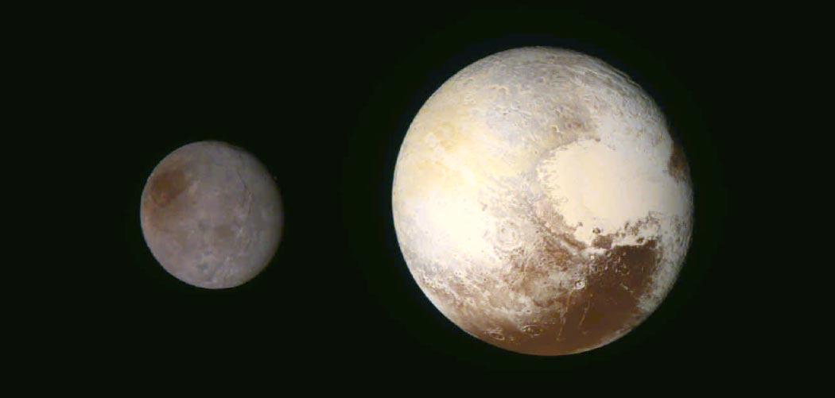
Pluto also has a moon, called Charon, that is almost as big as it is. The New Horizons spacecraft took photos of both Charon and Pluto. Pluto has a big heart-shaped region that the astronomers named Tombaugh, after the person who discovered Pluto. One of the craters on Pluto is named Elliot, after my friend Jim Elliot, who was one of the people who discovered Pluto's atmosphere.
Lots of people don't realize that "dwarf planet" is the most popular type of planet. There are probably hundreds of them. So now we have 8 planets and some large number of dwarf planets, of which we know of only 4 so far but we will find more.

Asteroids 5100 Pasachoff and 68109 Naomipasachoff are my favorite objects in the solar system. They are both in the asteroid belt, which lies between Mars and Jupiter. They take a few years to go around the Sun.
These asteroids are very faint, so you need a medium-sized telescope to see them. Even telescopes don't show details on their surfaces, but the telescopes show them moving from night to night compared with images of stars.
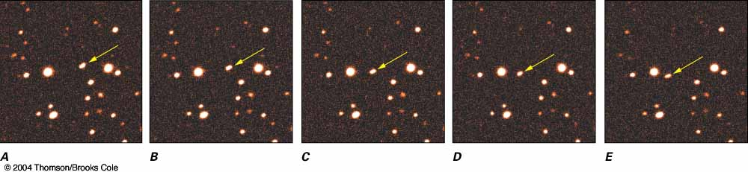
This photo shows asteroid Pasachoff, which was given the number 5100. The asteroid Naomipasachoff was discovered later, and was given the number 68109. They were both discovered at the Lowell Observatory in Arizona. They are about 2 and a half times farther out from the Sun than our Earth is, and they take about 4 years to orbit the Sun.

Here is the entry in Wikipedia for Naomipasachoff:
https://en.wikipedia.org/wiki/68109_Naomipasachoff
and details for both are at
http://sites.williams.edu/pasachoff/asteroid/
with Jet Propulsion Laboratory NASA listings at
http://ssd.jpl.nasa.gov/sbdb.cgi?sstr=5100
http://ssd.jpl.nasa.gov/sbdb.cgi?sstr=68109

